Solution: List Views

In previous labs, you created the Interaction_Ext entity and the InteractionReason_Ext typelist. You also modified the ABContact entity to capture interactions. In this lab, you will modify the Interactions page to display a list of contact interactions with a reusable list view panel.

Requirements

This lab requires that you use TrainingApp 8.0, Guidewire Studio 8.0, and a supported web browser. To view, edit, and delete various contacts, log in to TrainingApp as Alice Applegate. The default URL for TrainingApp is <http://localhost:8880/ab/ContactManager.do>. The login/password for Alice Applegate is aapplegate/gw.

1. Create a List View Panel

In this exercise, you will create a reusable list view panel for contact interactions.

Configuration

1. Open Guidewire Studio for TrainingApp
2. From Studio, if your server is not already running, start the server using Debug 'Server'.
3. Verify that the application is running in the Debug console without errors.
4. Create the InteractionsLV PCF File
5. Create the list view panel in the traininglabs PCF folder.  
   i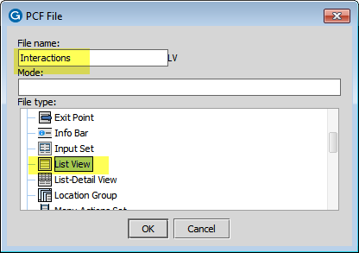
6. Specify a root object of the type ABContact.  
   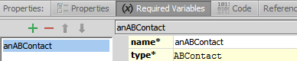
7. Configure the list view panel
8. Each row of the list view must display the following:
   * Interaction Date labeled as Date
   * Interaction Reason labeled as Reason
   * Associated User labeled as User
9. Modify the Interactions Page

In this exercise, you will add the InteractionsLV to the ABContactInteractionsPage PCF file.

Configuration

1. Navigate to ABContactInteractionsPage
2. In the canvas, hide included sections.
3. Replace the inline detail view panel
4. Delete the detail view panel.
5. Add a reference to the InteractionsLV.  
   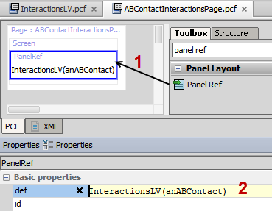
6. Add a toolbar to support paging of the list view panel.  
   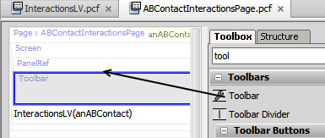

Deployment

1. Log in to TrainingApp
2. Log in as Alice Applegate.
3. Reload the PCF changes
4. In TrainingApp, reload the changes to the PCF file(s).

Verification

1. View the Interactions page for William Andy
2. Search for William Andy.
3. In the search results list view, navigate to the William Andy contact.
4. In the sidebar menu, click Interactions.
5. Verify that you see the Interactions list view panel on the Interactions page.

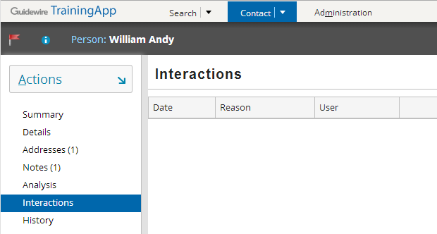

|  |  |
| --- | --- |
|  | Stop and ask your instructor to review your completed lab. |